Konjit Zewede - Media and Advocacy expert
Konjit Zewede is a media and advocacy expert, communication and public relations specialist with over ten years of experience across Ethiopia’s public and private media. She has worked with leading organizations including Fana Broadcasting Corporation as reporter and news anchor, and currently serves as Chief Editor at National Broadcasting Services (NBC) Ethiopia, one of the country’s leading broadcastings. Her career highlights include successful documentary production, government and community project follow-up, impactful news coverage, and advancing women’s empowerment initiatives across diverse sectors. Konjit combines technical excellence in media production with a strong commitment to gender equality and amplifying women’s voices.
Sara Moges – Media Executive
Sara Moges is an Ethiopian media executive, journalist, producer, strategic communications professional, trainer and author with more than a decade of experience in broadcasting, public relations, media research, broadcast programs production and leadership. She is Chief Executive Officer of Tirita FM 97.6, providing strategic, editorial, operational and business-development leadership while heading the Fact-Checking Desk to strengthen information integrity and public trust. She designs and delivers training on communication, content development, fact-checking, media literacy and awareness creation. Her career spans Tirita FM, NBC Ethiopia, Seba Dereja Media Network, Ethiopian Tourism Organization and cultural-event production. Sara holds an MA in Documentary Linguistics and Culture and a BA in Foreign Languages and Literature from Addis Ababa University. She is an author of the Amharic poetry collection ሰካራሙ ስንኞች.

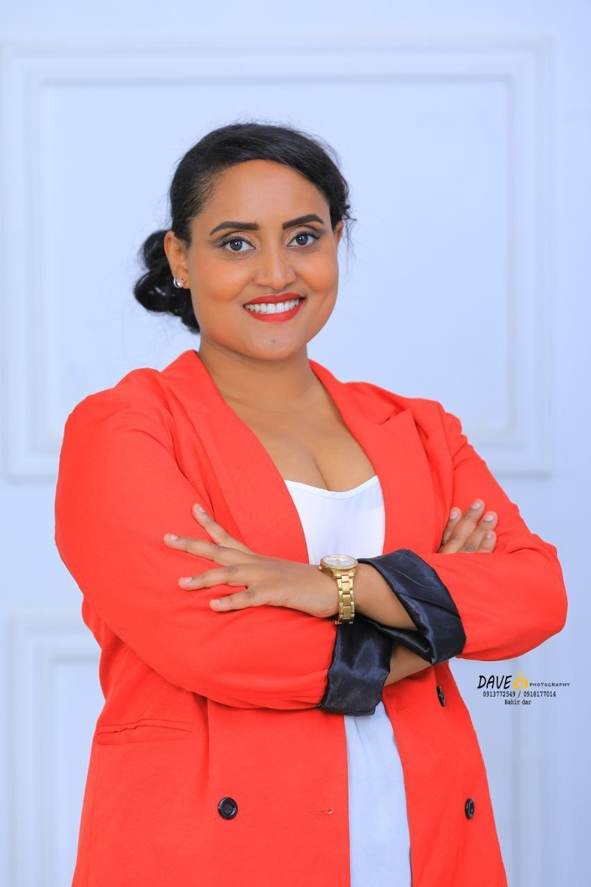
Fitih Alemu - Journalism Educator
Fitih Alemu is a journalism educator, researcher, media development professional and trainer with more than 13 years of experience in journalism teaching, corporate communication and public relations. She has worked extensively in strategic communication and project implementation, with a strong focus on advancing gender equality in Ethiopian journalism practice and education. As co-founder of the Ethiopian Journalism Educators’ Network, she has taught and mentored aspiring journalists at the university level and serves as a research and training consultant specializing in gender, media, communication and institutional capacity building. Her work includes initiatives that strengthen the role of women journalists, promote gender equality in media, and advance ethical, inclusive journalism.
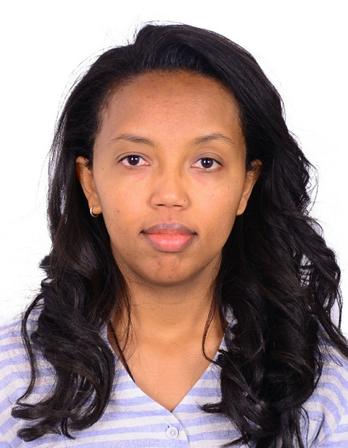
Mihret Aschalew - Media and Communications Specialist
Mihret Aschalew is a senior media and communications specialist with extensive leadership experience in international journalism, global development and public health. She currently serves as Communications Advisor at JSI, a U.S.-based international organization advancing global health and education. Her career includes senior roles such as Senior Editor at The Reporter Newspaper, Multimedia Journalist for BBC World Horn of Africa Service, Project Manager at BBC Media Action and Communications Officer for UN Women. Her expertise lies at the intersection of media, communications and gender advocacy. Mihret holds a Master’s in Journalism and Communication, a BA in Political Science, and specialized training in Project Planning and Management from Makerere University. She is a member of FEMNET.

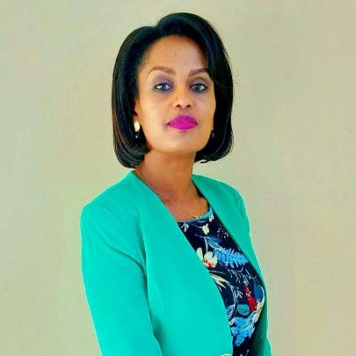
Tsega Tariku - Journalist and Media Leader
Tsega Tariku is a distinguished Ethiopian journalist and media leader with over sixteen years of dynamic experience at Fana Media Corporation. Rising from reporter to Editor-in-Chief, she has excelled as a radio host, television presenter and digital content creator. Her work is defined by specialization in gender, environment, health and business reporting, consistently championing gender advocacy across platforms. Holding a Master’s in Public Diplomacy from Jilin University, China. Tsega is also a trainer, public speaker, and regional media representative. Currently serving as Director of Branding, Creative and Quality control at Fana Media Corporation, she continues to shape impactful narratives and drive innovation in Ethiopian media.

